Summary

This document will help user to understand how to use additive manufacturing layer to include default needs for certain additive technologies.

|  |
| --- |
| User Documentation  for  Post Configurator Postprocessor  Additive Manufacturing Layer |

Executive summary

Ut wisi enim ad minim veni consectetuer adipiscing elit sed diami nonummy nib euismod tincidunt utlaoret dolore magna aliquam erat volutpat. Utlab enim ad minim veniam quis nostruted exercitis la tation ullamcorper suscipit lobortis nisl ut ali quip ex ea commodo consequat. Duis au tem vel eum irid dolor in hendre rit in vulputate velitesse monet con sequavel illum dolorem eu feugiatpat. Ut wisi enim ad minim veniam quis nostrud exerci tation mis et iusto odio dignissim qui blandit praesent luptatum zril dele netaugue duis dolore te feug ait nulla fac lisi. Lorem ipsum dolo.

Author (optional)  
Title (optional)

**User Documentation**

for

Post Configurator Postprocessor

Additive Manufacturing Layer

Table of Contents

1 Introduction 2

2 What is it 2

3 Import AM Layer 3

3.1 Import AM Post Configurator Layer 3

4 Function 4

5 How to use 5

5.1 Group Property 5

**5.1.1** Technology 5

**5.1.2** Additive Markers 5

**5.1.3** Cooling Time 6

**5.1.4** Deposition Output Data 8

**5.1.5** Merge Setting 9

**5.1.6** Motion Type Output 11

**5.1.7** Skip Tool Change 11

**5.1.8** Version Information 11

5.2 Technology Type DED 12

**5.2.1** DED subprogram 12

**5.2.2** UDE for Laser Powder Technology 12

**5.2.3** Power Levels DED 13

5.3 Technology Type – WAAM 14

**5.3.1** Technology parameters 14

**5.3.2** UDE Wire Arc Header 14

**5.3.3** Operation Parameters : 15

**5.3.4** Power Levels WAAM 16

**5.3.5** UDE Wire Arc Operation Parameters 16

**5.3.6** Job Number Buffer customization 16

5.4 Technology Type – FDM (Material Extrusion) 17

**5.4.1** Speed modulated 17

**5.4.2** Technology Parameters 17

**5.4.3** DWELL Time 19

6 Software Versions 20

7 Documentation History 20

# Introduction

While Additive Manufacturing is similar to Subtractive in many ways, there are also many differences, and these differences need to be taken advantage of in the post processing stage.

This document explains the functionality enabled by the Additive Manufacturing Layer.

The AM layer is encrypted and cannot be modified.

# What is it

The AM Layer includes elementary needs for 3 selected additive technologies and with this generic layer to the OOTB post processing allows a head start in the post processor creation.

Common functionality as well as technology specific settings are controlled by properties, UDE or internal calculation.

Proposed Technologies are:

* Laser Metal Deposition (DED, LMD,..)
* Wire Arc Additive Manufacturing (WAAM)
* Thermoplastic Material Extrusion (FDM, CFF,…)

This AM layer describes the basic needs for certain technologies and in most conditions it has not enough functionality included, so customization is possible on an additional customer layer.

Including enc (=encrypted tcl) and psl file. Post writer can import this layer by PC layer manager to any machining postprocessor. (Verified is the AM Layer for Sinumerik, Fanuc, RMR-Robot, ABB-Robot)

The Layer Manager helps you to import, create, export and sort Layers to or in a Postconfigurator Post.

# Import AM Layer

## Import AM Post Configurator Layer

Click Import Layer button of Layer Manager, choose sdis_additive.psl in browser.

[HELP](https://docs.plm.automation.siemens.com/tdoc/nx/1899/nx_help#uid:xid1128418:index_mfgpostconfig:xid1487919:xid1446295)

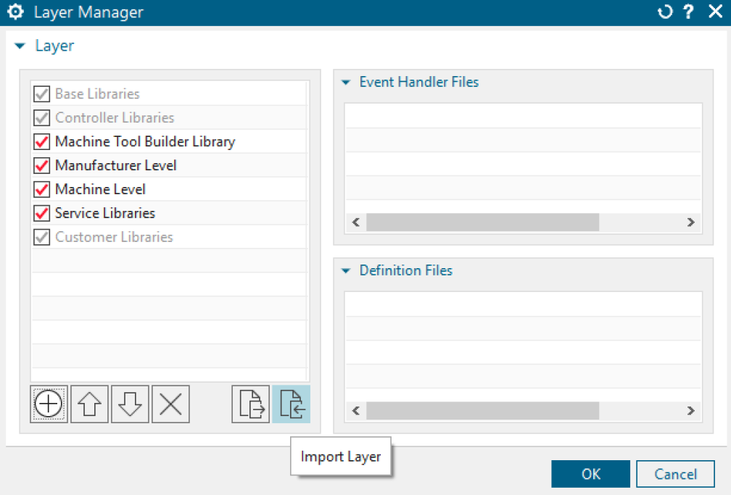

The position of the AM Layer should be always directly before the Service/Customer layer.

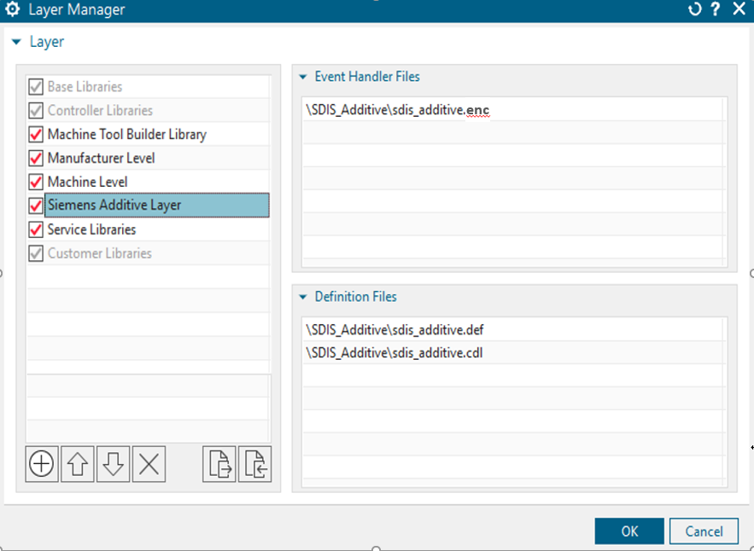

# Function

Once this layer is imported into the postprocessor, inter property condition is implemented.

Some properties or UI objects will be visible or invisible based on their master property value

* One of the fundamental features is recognizing and replacing a certain motion type to the “Deposition” motion type.
* All group properties which are listed includes common settings for every technology.

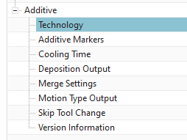

* If certain technology (DED, WAAM, FDM) in drop-down list is selected, then there are only possible properties are available which are necessary for these type of technology

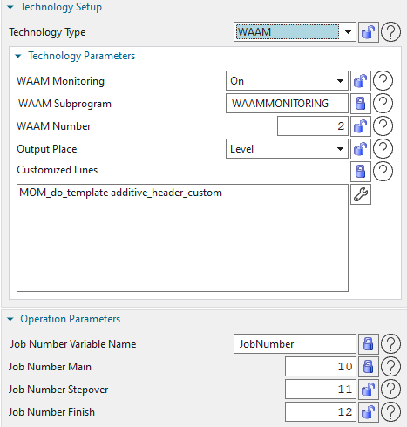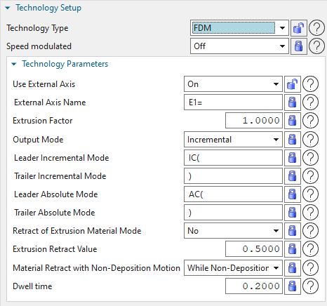

* Merge group workflow is supported without any additional work.

# How to use

## Group Property

### Technology

Choose specific technology

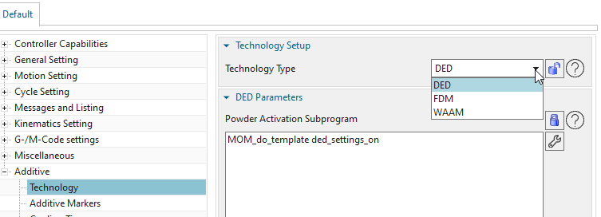

### Additive Markers

Based on the Multi Axis Deposition operations, there are a bunch of different markers included in the toolpath.

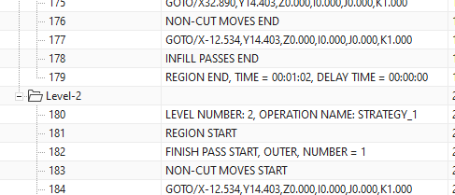

Turn on the different marker properties enables to customize output at specific marker which are available in the AM layer.

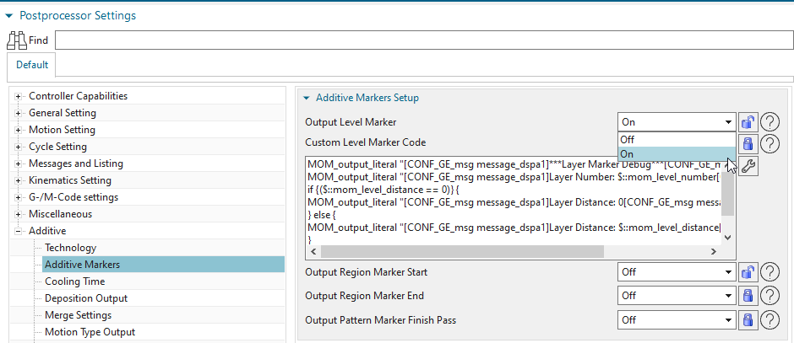

### Cooling Time

The deposition process deposits material using fusion, which generates heat. When you build a part layer by layer, the material requires time to cool down before more layers can be added. While the deposition of one layer in a large part may allow enough time to cool down before starting the next layer, a smaller part may be require some amount of wait time to let the material cool down…….

The full description how to control in the operation is referenced in NX Help:

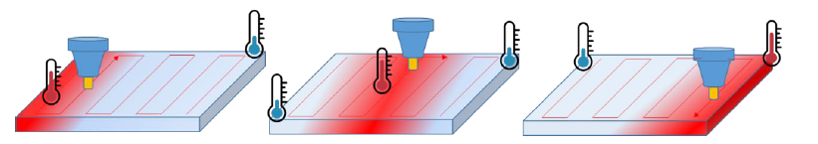

[NX HELP DOCUMENTATION](https://docs.sw.siemens.com/en-US/product/209349590/doc/PL20200507135732916.xid1256571/html/xid1434168)_LINK

The output of the cooling/delay time is organized in a block template. This block template can be customized or you can create a new block template with another name. If you are using another block template you have to change the property entry “Cooling Time Template Name”.

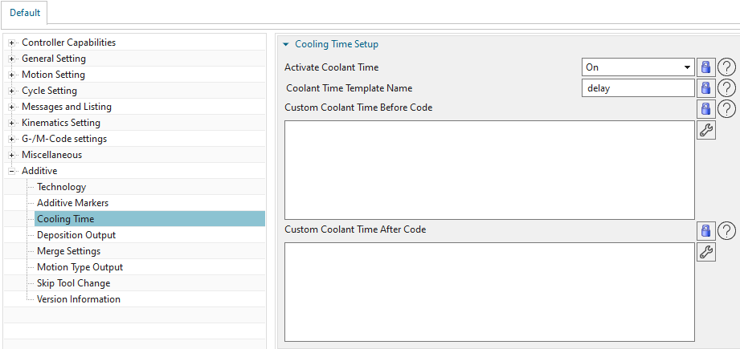

With two command-blocks you have the ability to include custom code before or after the cooling-time-output is output.

### Deposition Output Data

In this area, everything is about the command for deposition on and deposition off.

As described in point 3 “Function” the AM layer recognizes when a deposition toolpath is active.

#### Deposition ON/OFF

* Most AM machines needs a command to activate and deactivate the additive process.

Include the STRING of the NC-command into the properties and define the blocktemplate

* Depositon on
* Deposition off
* Deposition Output Block Template Name (block template)
  + Create own Block Template for on/off is possible

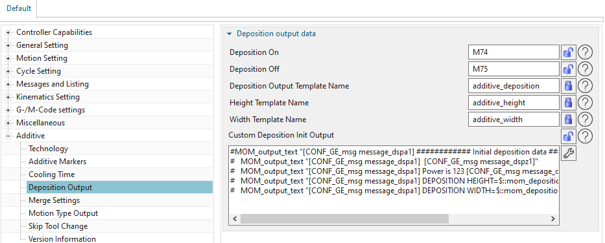

#### IPW Simulation

IPW Simulation is one important feature in NX CAM. And it is a big advantage with CSE simulation. With the output about the bead height and the bead width it is possible to simulate the IPW in the CSE simulation.

You have to customize the CSE simulation for IPW simulation.

Include the STRING of the Block Template into the properties which is responsible for the output.

* Height Template Name
* Width Template Name

**The Block Templates are using mom variables and can be customized**

* **“mom_deposition_height”**
* **“mom_deposition_width”**



### Merge Setting

With a merge path it is possible to merge different additive operations. This has a lot of advantages. For more information on merging, see the NX Help

For more information please go [here](https://docs.sw.siemens.com/en-US/product/209349590/doc/PL20200507135732916.xid1256571/html/xid1340743).

To keep track of the NC-program and the structure the AM layer has got the possibility to include information on the correct position. The AM layer identifies by “start/end of mergedpath” the merge scenario and you can customize with the command block the output at the merging point.

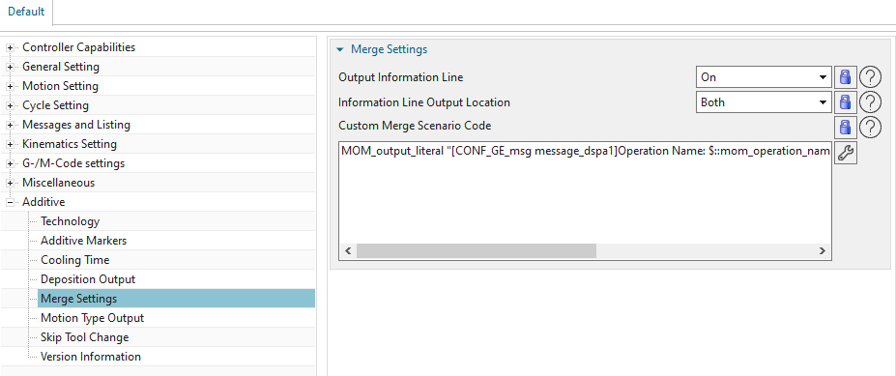

### Motion Type Output

This setting outputs the different motion types. (mom_motion_type)

There are 3 settings to choose from:

* Off
* Always
  + Inline (output in same line with a controller dependent character for comments)
* On change
  + Inline
  + Before
    - Integrates a new line for the motion output comment
    - Or comments are customizable with the command block

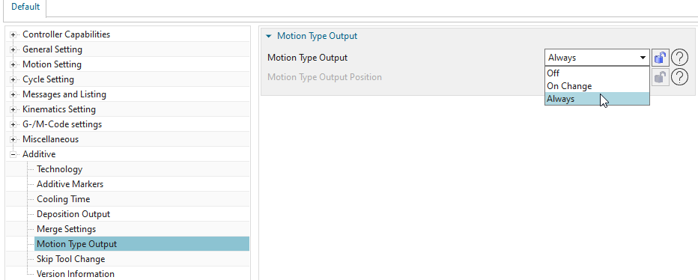

### Skip Tool Change

Skip the tool change in a Merge Path when it is ON

### Version Information

AM Layer Release information

## Technology Type DED

The DED Layer uses simple output for which is described in the whole section 5.1.

### DED subprogram

In many AM DED machines it is needed to activate a subprogram which includes some

technology specific parameters. In this situation you can customize with the command block specific subprogram.

In the default example which is prepared for a Laser Powder additive technology it looks like this.

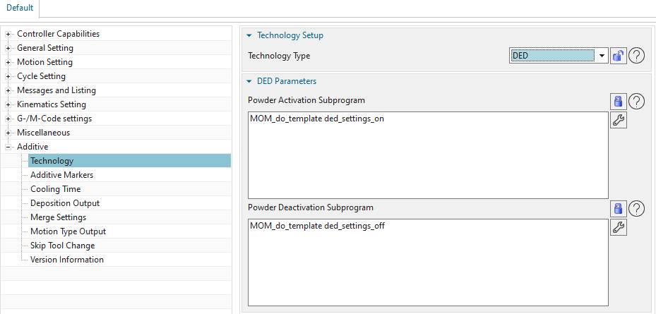

### UDE for Laser Powder Technology

The values for the subprogram are defined in an **UDE.**

Please attach this UDE to the START EVENT from the operation or the method.

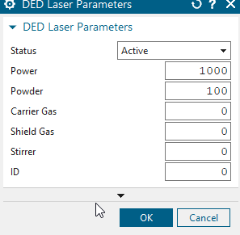

### Power Levels DED

Power Level values are be outputted as Power values

These values can be added in a singles line for each level and updates the Start Laser Power STRING in the UDE.

The last value of the power levels stays for the rest of the levels.

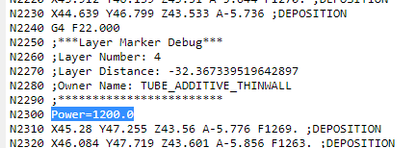

## Technology Type – WAAM

### Technology parameters

**Wire Arc Header** – When user want to get necessary technology information in the program h

Controlled with Subprogram

Property for Header subprogram name, e.g. WAAMMONITORING

* WAAMMONITORING: OFF / ON
* Definition of variable name (WAAM subprogram) in Post Configurator
* Monitoring number can be defined
* Monitoring can be outputted as
  + header/group (once a time at each program folder)
  + operation
  + every level
* Possibility to add some customized lines afterwards is available in the open command block

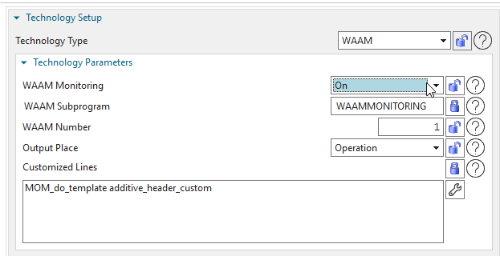

### UDE Wire Arc Header

An UDE is available as well. With that UDE the technology parameters can be changed every operation or group. Also, it could be attached on a method.

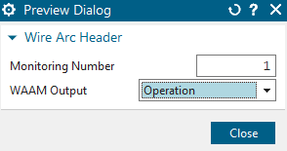

### Operation Parameters :

* Wire Arc operation parameters – If user want to get necessary technology information for the operations and control the job numbers by UDE.
* Controlled by UDE which will be attached to operations or methods group.
* Job number variable name defined by property in Post Configurator.
* Job number definition: integer number assigned by the user

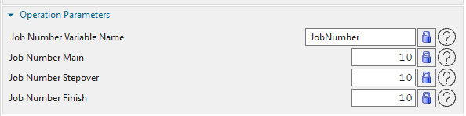

Job number main – integer

Job number is modal and always before Deposition ON except if UDE is used in Apply Rules

Job number stepover – integer

Job number stepover is used when a value for this item is included (maybe an activation could be useful).

Also, if function “Deposition on Stepover is on”



NC-Code:

When stepover job number should be included, then it is without any Deposition ON/OFF output

After stepover please use “Job number main” again

Job number finish passes - integer

Job number is modal and always before Deposition OFF except if UDE is used in Apply Rules

### Power Levels WAAM

Power Level values are be outputted as job numbers main.

These values are be used instead of the values in the “PC UI” or in “UDE Wire Arc Operation Parameters”.

The last value of the power levels stays for the rest of the levels.

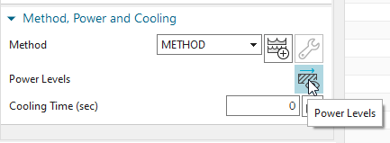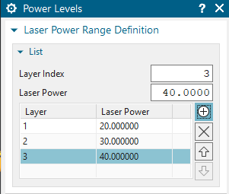

### UDE Wire Arc Operation Parameters

An UDE is available as well. With that UDE the technology parameters can be changed every operation or group. It could be attached on a method, too.

Job number main = ude value

Job number stepover = ude value

Job number finish passes = ude value

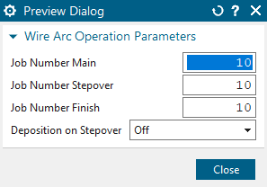

### Job Number Buffer customization

For the different type “JobNumber” it is an own buffer available. You can see it in debugging mode of PC.

* @UDE_job_number_main
* @Jobnmbr_Power_Level

## Technology Type – FDM (Material Extrusion)

### Speed modulated

For “Bowden setups”, i.e. FFF systems with a rather long distance between Extruder motor (“cold end”) and nozzle (“hot end”), there is a significant delay between extruder feed changes and a change in material flow through the nozzle.

Therefore the extruder feed rate should be kept constant and the desired extrusion rate is achieved by varying the nozzle feed rate along the path.

*ON/OFF: Material flow value mm³/s (default 1)*

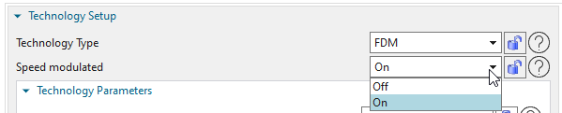

### Technology Parameters

#### Use External Axis

The deposited geometry is defined by the combination of two machine movements. One of them is the motion of the nozzle related to the toolpath, which is already there.

Turn it ON and it outputs an additional axis for material extrusion.

Definition of the characters of the additional axis could be controlled as followed

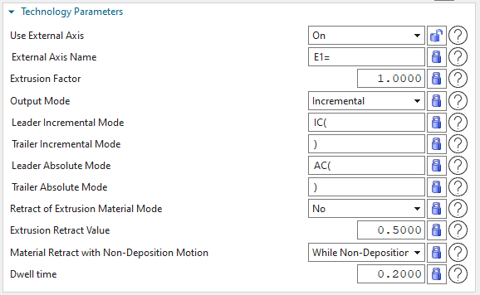

#### Extrusion Factor External Axis

In respect to the material extrusion axis, this factor is necessary to define the material flow rate.

For “simple” printing setups, the extrusion factor is set by the user as a fixed value.



The calculation formula is followed:

***mom_motion_distance / extrude_factor***

#### Output Mode External Axis

Output Mode for the calculation of the extrusion axis value



#### Retract of Extrusion Material Mode

The material flow through the nozzle will not stop immediately when the extruder stops. Therefore a possible solution could be that material is retracting a defined distance.

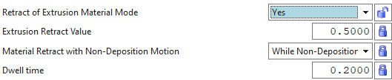

The calculation formula is followed:

***(mom_motion_distance / extrude_factor)-retract value***

* Retract of Extrusion Material Mode
  + ON /OFF
* Extrusion Retract Value
  + Set the value for extrusion retract, the default value used is 0.5000



* Material Retract with Non-Deposition Motion



### DWELL Time

The material flow through the nozzle will not start immediately when the there was a retract before.

Therefore to reactivate the material flow, before the real deposition starts again is used with a waiting time.



* Unit is second
* Output is always “after Engage” and “before Retract”

# Software Versions

This document has been created and maintained for below versions,

|  |  |
| --- | --- |
| **NX Version** | **Comment** |
| NX 1953 |  |

|  |  |
| --- | --- |
| **AM Layer Version** | **Comment** |
| V1.13 |  |

# Documentation History

|  |  |  |
| --- | --- | --- |
| **When** | **Who** | **What** |
| 17-Sept-2021 | Rybarz Andreas | Initial version |
|  |  |  |
|  |  |  |
|  |  |  |